3.1 Project Planning (Product Backlog, Sprint Planning, Stories, Story points)
Date | 10 July 2026
Team ID
Project Name | Book a Doctor App
Maximum Marks | 5 Marks

Product Backlog, Sprint Schedule and Estimation
Sprint | Functional Requirement (Epic) | User Story Number | User Story / Task | Story Points | Priority | Team Member
Sprint-1 | User Registration | USN-1 | Patient can register using personal details. | 3 | High | Team Member 1
Sprint-1 | User Login | USN-2 | Patient can securely log in using email and password. | 2 | High | Team Member 1
Sprint-1 | Doctor Registration | USN-3 | Doctor can register and submit profile details. | 3 | High | Team Member 2
Sprint-1 | Admin Login | USN-4 | Admin can log in securely. | 2 | High | Team Leader
Sprint-2 | Appointment Booking | USN-5 | Patient can search doctors and book appointments. | 5 | High | Team Member 2
Sprint-2 | Appointment Management | USN-6 | Doctor can approve or reject appointments. | 5 | High | Team Member 3
Sprint-2 | Doctor Availability | USN-7 | Doctor can update available slots. | 3 | Medium | Team Member 3
Sprint-3 | Medical Report Upload | USN-8 | Patient can upload medical reports securely. | 3 | Medium | Team Member 4
Sprint-3 | Appointment History | USN-9 | Patient can view previous appointments. | 2 | Medium | Team Member 1
Sprint-3 | Notifications | USN-10 | User receives appointment confirmation notifications. | 2 | Medium | Team Leader
Sprint-4 | Admin Dashboard | USN-11 | Admin manages doctors, patients and appointments. | 5 | High | Team Leader
Sprint-4 | Final Testing & Deployment | USN-12 | Complete testing, bug fixing and deployment. | 5 | High | Entire Team

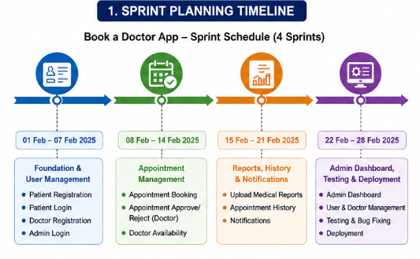
Project Tracker
Sprint | Total Story Points | Duration | Sprint Start Date | Sprint End Date (Planned) | Story Points Completed | Sprint Release Date
Sprint-1 | 20 | 7 Days | 01-Feb-2025 | 07-Feb-2025 | 20 | 07-Feb-2025
Sprint-2 | 20 | 7 Days | 08-Feb-2025 | 14-Feb-2025 | 20 | 14-Feb-2025
Sprint-3 | 20 | 7 Days | 15-Feb-2025 | 21-Feb-2025 | 20 | 21-Feb-2025
Sprint-4 | 20 | 7 Days | 22-Feb-2025 | 28-Feb-2025 | 20 | 28-Feb-2025

Velocity
The development of the Book a Doctor App was planned across 4 sprints, with each sprint consisting of 20 story points over a duration of 7 days.
Average Velocity Calculation
Total Story Points Completed = 80
Total Number of Sprints = 4
Average Velocity = 80 ÷ 4 = 20 Story Points per Sprint
Average Velocity per Day = 20 ÷ 7 ≈ 2.86 Story Points per Day
This indicates that the development team consistently completed approximately 20 story points in each sprint, demonstrating effective sprint planning and steady project progress.

Burndown Chart
